Name_____________________________________________________Date_____________________
Volume: Finding the Number of Cubes in a Prism

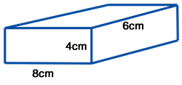
Problem 1:
The right rectangular prism-shaped box shown is filled with one-centimeter cubes.
How many one-centimeter cubes fit within the prism?

What is meant by one-centimeter cubes?

Problem 2:
The right rectangular prism-shaped box shown is filled with two-centimeter cubes.
How many two-centimeter cubes fit within the prism?

What is meant by two-centimeter cubes?

Problem 3:
The right rectangular prism-shaped box shown is filled with 0.5--centimeter cubes.
How many ½ -centimeter cubes fit within the prism?
3 cm

2 cm
1 ½ cm

What is meant by ½ -centimeter cubes?

Problem 4:
Small cubes with edge lengths of ¼ inch will be packed into the right rectangular prism shown.
How many small cubes are needed to completely fill the right rectangular prism?
What is meant by cubes with edge length of ¼ inch?

2 in
1 ½ in.
2 ½ in.

