Name________________________________Class_____________Date___________

Modeling Fraction Multiplication

**DIRECTIONS: MODEL THE FOLLOWING PRODUCTS USING ONE OF THE METHODS DISCUSSED IN CLASS.**

EXAMPLE: *Fraction of a Fraction Model*



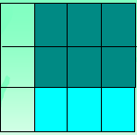

1.  **Product:** 2.  **Product:**

3.  **Product:** 4.  **Product:**

5. Create a fraction multiplication problem and model the product below.

Problem: ____________________

Model:

6. What questions do you still have regarding modeling fraction multiplication?