Cumulative Geometry Quiz Menu

Name: _________________________________Class: ______________________ Due:______________

DIRECTIONS:
- All items in the main dishes must be complete by the due date.

Main Dishes (complete all)
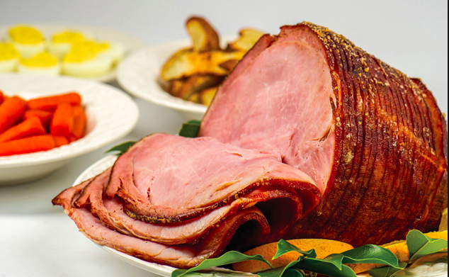
- Study the formulas below.

  - Area of a Rectangle = _____________________

  - Area of a Triangle = _______________________

  - Volume of a Rectangular Prism = ______________________

  - Volume of a Prism = _____________________

- Make sure your Fractions Unit table of contents in your binder is up-to-date. (You should have up to page 20.)

- Make sure that all of your notes sheets are filled in. If not, navigate to the math weebly page.

- Complete Weekly Practice Packet #7

- Correct the Weekly Practice Packet and think deeply about your mistakes (I should see correction marks in your packet with the correct answers and corrected work written in.)

- Study your red and white foldables to help understand and recall the following vocabulary:

volume area cube unit cube edge-length rectangular prism Base

