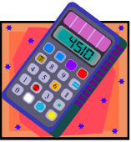
Name___________________________Class________Date__________

Weekly Practice Packet #7:
Geometry Review

The weekly practice packet is due on _________________________________.

Complete the problems in the packet throughout the week as you learn more about each skill or concept. It is important that you try your best and persevere when solving each problem or answering each question. The weekly practice packet counts as a 10-point nightly practice grade.

If you get stuck do the following:

- Refer to your class notes, practice sheets, and warm-ups.
- Take a break and try the problem or question again.
- Attend Mrs. Brightman’s extra help sessions.
- Still having trouble? Write a statement stating why you are having difficulty on the problem or question.

PART I: AREA (notes pages 12, 13, 14, 15)

- Find the area of the following figure. Convince me by showing your “proof” below. Write your answer in a complete sentence.
6 in

3 in

Sentence: ____________________________________________________

- Find the area of the following figure. Convince me by showing your “proof” below. Write your answer in a complete sentence.
$$5\frac{1}{3}in$$

$$1\frac{1}{2}in$$

Sentence: ____________________________________________________

- Find the area of the following figure. Convince me by showing your “proof” below. Write your answer in a complete sentence.
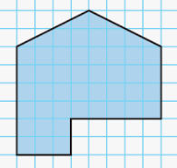

Sentence: ____________________________________________________

- Find the area of the following figure. Convince me by showing your “proof” below. Write your answer in a complete sentence.
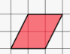

Sentence: ____________________________________________________

PART II: VOLUME (notes pages 16, 17, 18, 19, 20)

- Find the volume of a cube with an edge length of 3 inches. Show your thinking.

- Find the volume of a cube with an edge length of ¼ yard. Show your thinking.

- What is the volume of the rectangular prism below? Convince me by showing your “proof” below. Write your answer in a complete sentence.

$\frac{1}{2}$ cm
$\frac{6}{7}$cm
$2\frac{3}{4}cm$

Sentence: ____________________________________________________

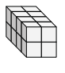
- How many cubes are in the rectangular prism below? Show your thinking. Write your answer in a complete sentence.

Sentence: _______________________________________________

- Suppose each small cube had an edge length of 5 cm. Find the volume of the rectangular prism. Convince me by showing your “proof” below. Write your answer in a complete sentence.

Sentence: ________________________________________________

- Suppose each small cube had an edge length of ½ in. Find the volume of the rectangular prism. Convince me by showing your “proof” below. Write your answer in a complete sentence.

Sentence: ________________________________________________

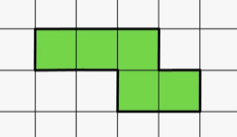
- The figure below is the footprint of a building. Find the volume of the building if it is 3 ½ units high. Convince me by showing your “proof” below. Write your answer in a complete sentence.

Sentence: ____________________________________________________
- Small cubes with edge lengths of ½ inch will be packed into the rectangular prism shown. How many small cubes are needed to completely fill the rectangular prism? Convince me by showing your “proof” below. Write your answer in a complete sentence.
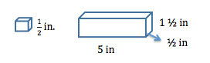

Sentence: ______________________________________________________

- The hot tub pictured below is in the shape of a rectangular prism. Determine how much water (in cubic yards) the hot tub can hold. Convince me by showing your “proof” below. Write your answer in a complete sentence.
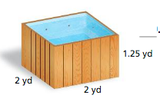

Sentence: ______________________________________________________

